EENG 3920: Modern Communication Systems Design

# **Lab 7 - Experiment 24: Tone Decoder**

Group 5

Victor Rodriguez (victorcuba92@gmail.com)

Mohammad Qawash (MohammadQawash@my.unt.edu)

John Rolfe (JohnRolfe@my.unt.edu)

Natalie Powers (NataliePowers@my.unt.edu)

Nathan Ruprecht (nathan.ruprecht@outlook.com)

**Date of Submission: 05 May 2016**

**Section 1**

**Introduction and Learning Objective**

EENG 3920 is the project design course for electronics courses. Students are required to design electronic communication systems with electronic devices such as MOS transistors, capacitors and resistors. The design and simulation tool is NI ELVIS platform. Topics include LC circuits and oscillators, AM modulation, SSB communications, and FM modulation. At the end of the class, the student should be able to: Understand fundamental concepts and circuits used in communication systems; Describe principles and theory of various communication techniques such as AM, FM, and SSB; Conduct effective analysis and interpretation of the experiments; Demonstrate the ability to identify, analyze, and solve technical problems; Creatively apply the course topics to designs; Simulate and analyze advance electronics circuits with NI ELVIS instruments and other test equipment.

For this experiment we investigated the behavior of a negative clamper, studied class C bias and amplification, and understood the theory of frequency multiplication.

**Safety guidelines**

As mentioned in the lab procedures, safety is extremely important in the lab. In the event of electrical fire, the session 1 lecture note states to use the fire extinguisher, located at the front of the lab, then to vacate the lab, close the door and ring the fire alarm.

**Section 2 / 3**

**Theoretical Background**

The objectives of this lab was to investigate frequency sensing and detection, to investigate the bandwidth and sensitivity of a tone decoder, and to build and test a tone decoder circuit.

**Exercises**

Procedure:

The prelab included calculating the theoretical fundamental frequency and bandwidth of our circuit by looking up the data sheet for the LM567 tone decoder. Fo is 1.1/R1C1 which came out to be 11 kHz. Since Vin was 1Vrms, we found the bandwidth by multiplying fo by C2. We got 51.7 which was closer to 62. According to table 2 in the data sheet, a result of 62 would mean the bandwidth is 2% of fo which would be 220Hz. Since we got 51.7, we assumed our bandwidth would be close to 220 Hz.

We built the required circuit and followed the instruction step by step. Without connecting the function generator, we adjusted the potentiometer until the oscilloscope showed a frequency of fo: 11 kHz.

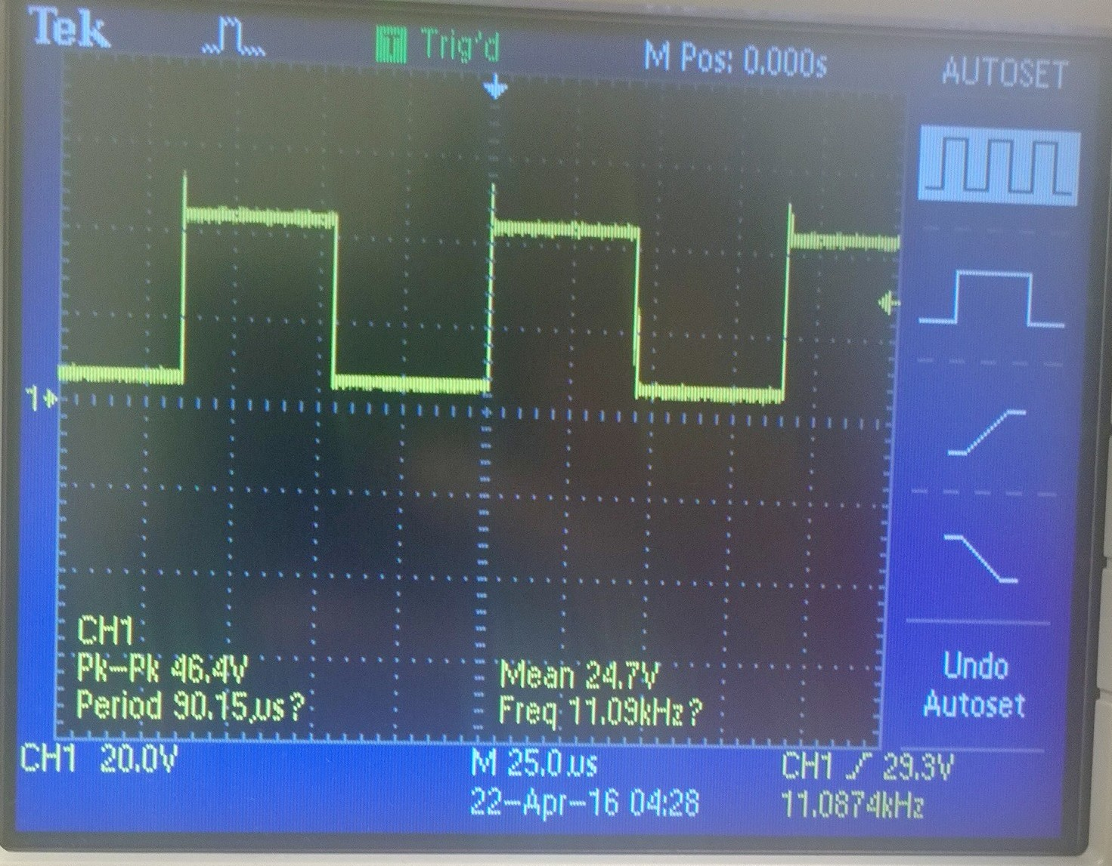

Output of o-scope to show frequency at fo: 11 kHz

Once it did, we hooked up the function generator to the circuit set at fo and 1Vrms. We found that the minimum voltage required to keep the LED lit was at ~17 mVrms. At this voltage, we increased the frequency of the generator until the LED turned off. That frequency was at 11.12 kHz. When we decreased the frequency until the LED turned off, we found that lower boundary to be at 10.94 kHz. This means the bandwidth was 180 Hz. The bandwidth percentage is the bandwidth / fo * 100 which is 1.63% for what we just did.

We increased the function generator voltage to 200 mVrms and repeated the process to find the upper and lower boundaries for this new and increased voltage level. We found the upper limit to be 11.24 kHz and lower boundary to be 10.81 kHz making the bandwidth 430 and the bandwidth percentage at 3.91%.

**Section 4**

**Conclusion**

In the end, we followed the instruction to the t and had a successful lab. We assumed the BW would be around 220 Hz meaning 2% of fo. In reality, it was 180 Hz making it 1.63%. This is incredibly close to our theoretical values so we considered it a success.

Follow up questions:

1. What is the bandwidth % of the tone decoder at the minimum input voltage level?

1.63% as explained in the exercises section.

2. What happened to the bandwidth when the input voltage was increased?

The bandwidth would also increase if we increased the voltage level.

# **References**

Agilent Technologies, 2007, *Agilent 34401A 6 ½ Digit Multimeter, User’s Guide*.